Canberra Times

An all-embracing view of the world
GRAHAM DOWNIE, RELIGION REPORTER
11 Feb, 2012 01:00 AM

Some will see it as an unholy mix, but tomorrow's mid-morning service at St James Uniting Church in Curtin will focus on evolution, nature, science and religion.
St James' minister Roger Munson says many religious people understand evolution is sound science.
''For them, it does not in any way threaten, demean, or diminish their faith in God,'' he said.
Evolution Weekend explored how science and evolution could help to draw diverse religions together.
''Many faith traditions find themselves in harmony with the tenets of modern science and embrace this shared purpose. While respecting differences, finding the common ground helps promote broader understanding among religions,'' he said.
Mr Munson, previously an Anglican priest in Victoria, said while there were some people who saw religion and science as at odds, these people invariably viewed religion through a very narrow lens.
''Those who have a far more nuanced view of religion reject the attempt to define religion in the image of one group,'' he said.
Mr Munson said that at tomorrow's 10.30am service he would discuss the dialogue between faith and science. He would draw on evolution poetry and the writings of Charles Darwin in the liturgy.
Though many mainline Christian churches generally accept evolution and Christianity are not in conflict, Mr Munson said churches were often embarrassed to discuss it.
''They would rather leave it as a sleeping dog,'' he explained. His church wanted to emphasise evolution because it gave a new perspective on what it was to be human.
''We no longer believe the world is sinful because of the myth of Adam and Eve ... We don't have a God who judges but rather a God who calls us into life.''
He said the theology of St James, Curtin was a little different to that of the mainstream Uniting Church.
''We are looking to modern insights which call us on. We have a favourable view of science.''
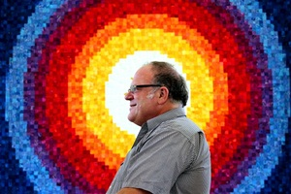
TRADITIONS: Minister at St James Uniting Church in Curtin, Roger Munson, believes there should be no conflict between religion and science.

